

**ONLINE MOVIE TICKET BOOKING SYSTEM**

## **PYTHON PROJECT REPORT**

***Submitted by***

|  |  |
| --- | --- |
| **DINESH KUMAR I.** | **[2303722813421013]** |

**BACHELOR OF ENGINEERING**

## *in*

**COMPUTER AND COMMUNICATION ENGINEERING**

**SRI ESHWAR COLLEGE OF ENGINEERING**

**(AN AUTONOMOUS INSTITUTION)**

**COIMBATORE – 641 202**

**APRIL - MAY 2024**

**BONAFIDE CERTIFICATE**

Certified that this project report **“ONLINE MOVIE TICKET BOOKING SYSTEM**” is the bonafide work of

|  |  |
| --- | --- |
| **DINESH KUMAR I.** | **[2303722813421013]** |

who carried out the project work under my supervision

|  |  |
| --- | --- |
|  | …………………………………  **SIGNATURE**  **Dr. C. GANESH , M.E.,Ph.D**  **SUPERVISOR**  Assistant Professor,  Dept. of Computer & Communication Engineering,  Sri Eshwar College of Engineering,  Coimbatore-641202. |

**TABLE OF CONTENTS**

|  |  |  |
| --- | --- | --- |
| **S.NO.** | **TITLE** | **PAGE** |
| 1. | Abstract | 01 |
| 2. | Introduction | 01 |
| 3. | Hardware and Software Specifications | 01 |
| 4. | Architecture | 02 |
| 5. | Project Code | 03 |
| 6. | Result-Snap Shots | 16 |
| 7. | Result and Discussion | 20 |

Online Movie Ticket Booking System

# Abstract:

In this project we book ticket using “Online Movie Ticket Reservation System”. We enter into Web page by logging with User Name and Password. Then we select the Movie and later in which Theatre movie is running.

Later choose Show Timings and enter no of tickets you want .Finally it displays the details of the procedure and print the form to show at respective ticket counter to get ticket.

1. **Introduction:**

The main purpose of our online ticket booking system is to provide an alternate and convenient way for a customer to buy cinema tickets. It is an automatic system. After the data has been fed into the database, the staff does not need to do anything with the order once it is received through the system.

# Hardware and Software specifications:

* 1. Software Requirements:

Operating System : Windows

Client side Technology : Python Database : MongoDB

* 1. Hardware Requirements:

Intel Pentium

Processor speed-1.2 GHz or above 1 GB RAM minimum

1024 GB Hard Disk Space

# Architecture – DFD:

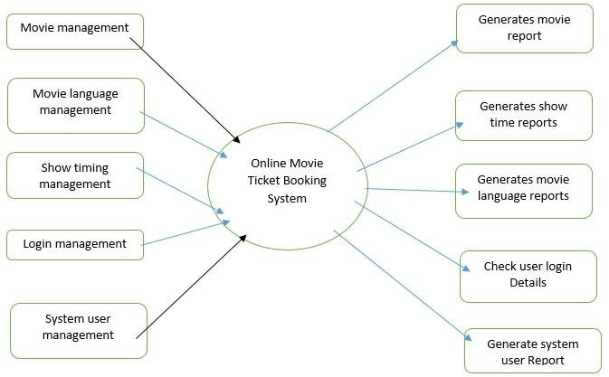

* 1. Modules:
     + User login module
     + Selection of Movie module
     + Selection of show time module
     + Selecting Theaters module
     + Number of Tickets booking module
     + Display booked Tickets with Amount

1. **Code for the Project**

5.1 index.html

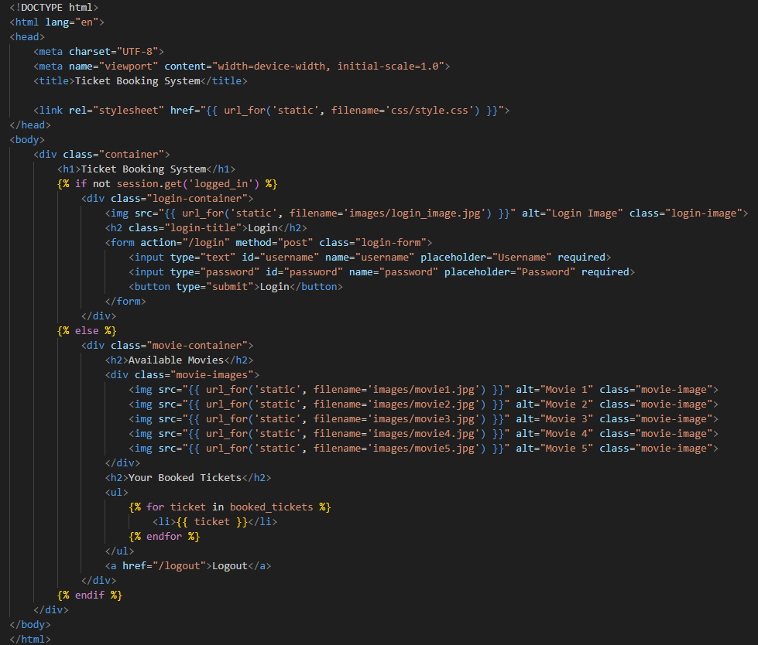

5.2 movies.html

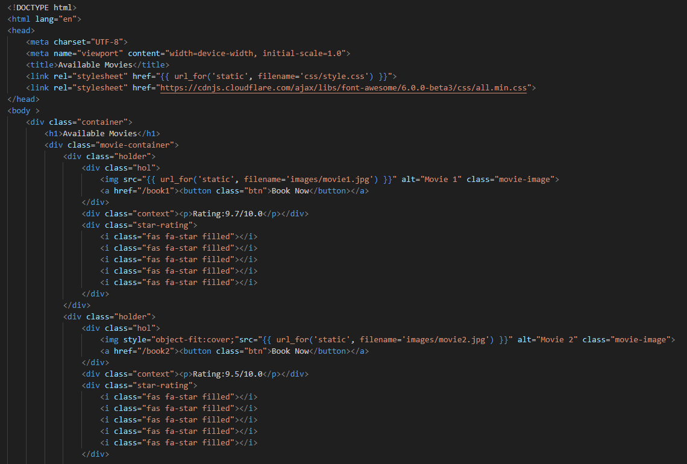

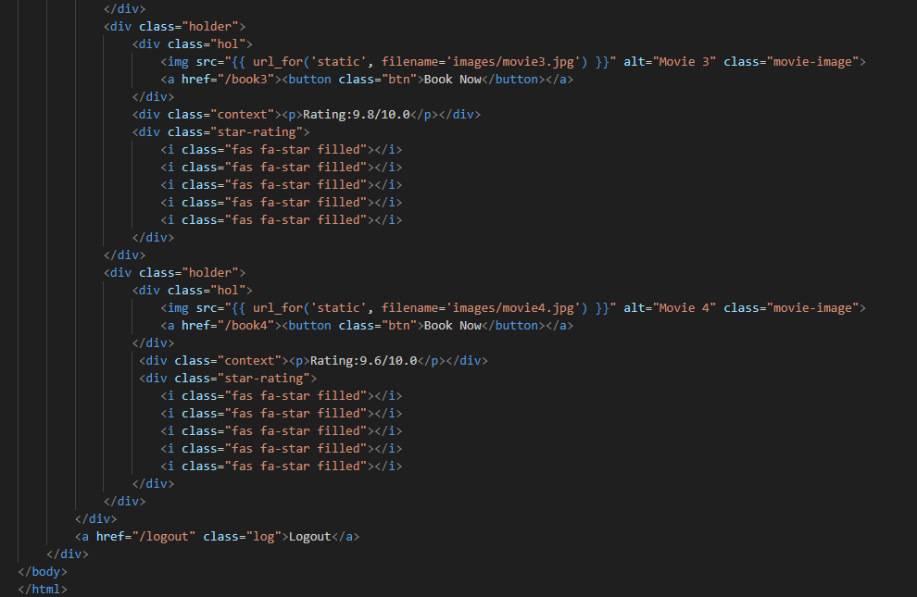

5.3 book1.html

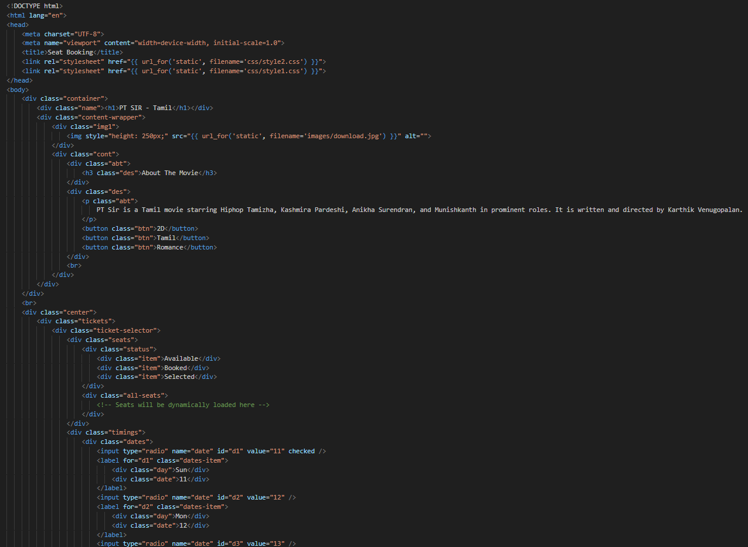

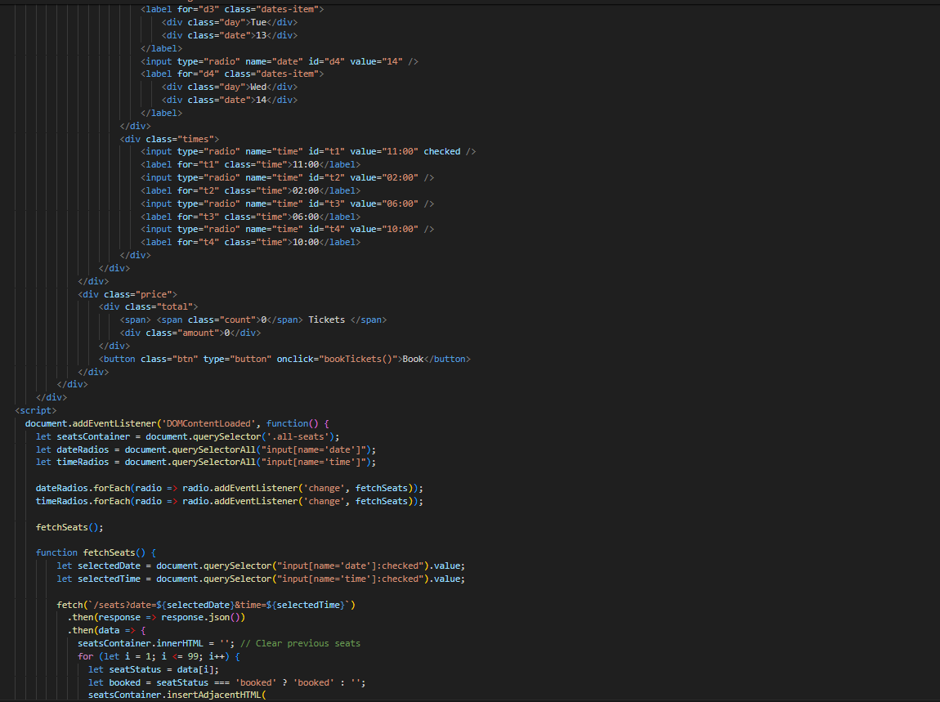

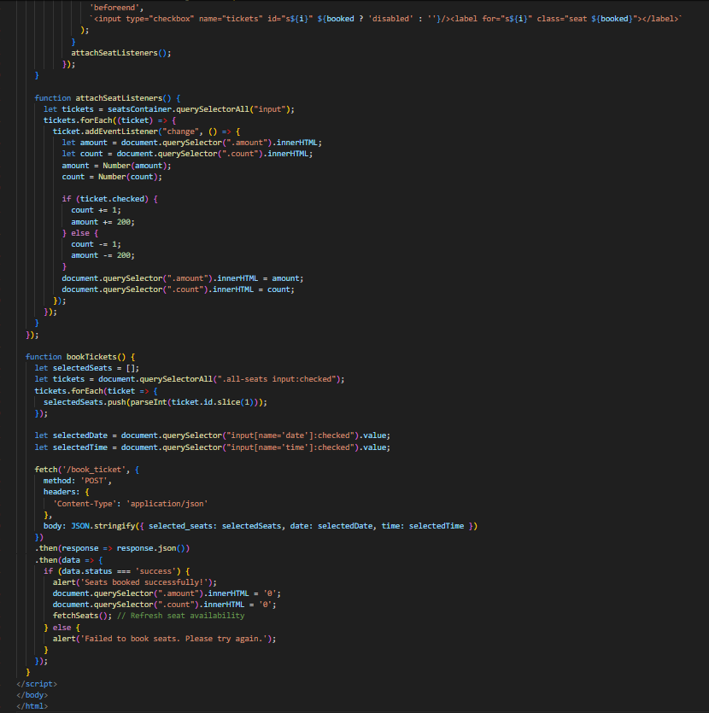

5.4 book2.html

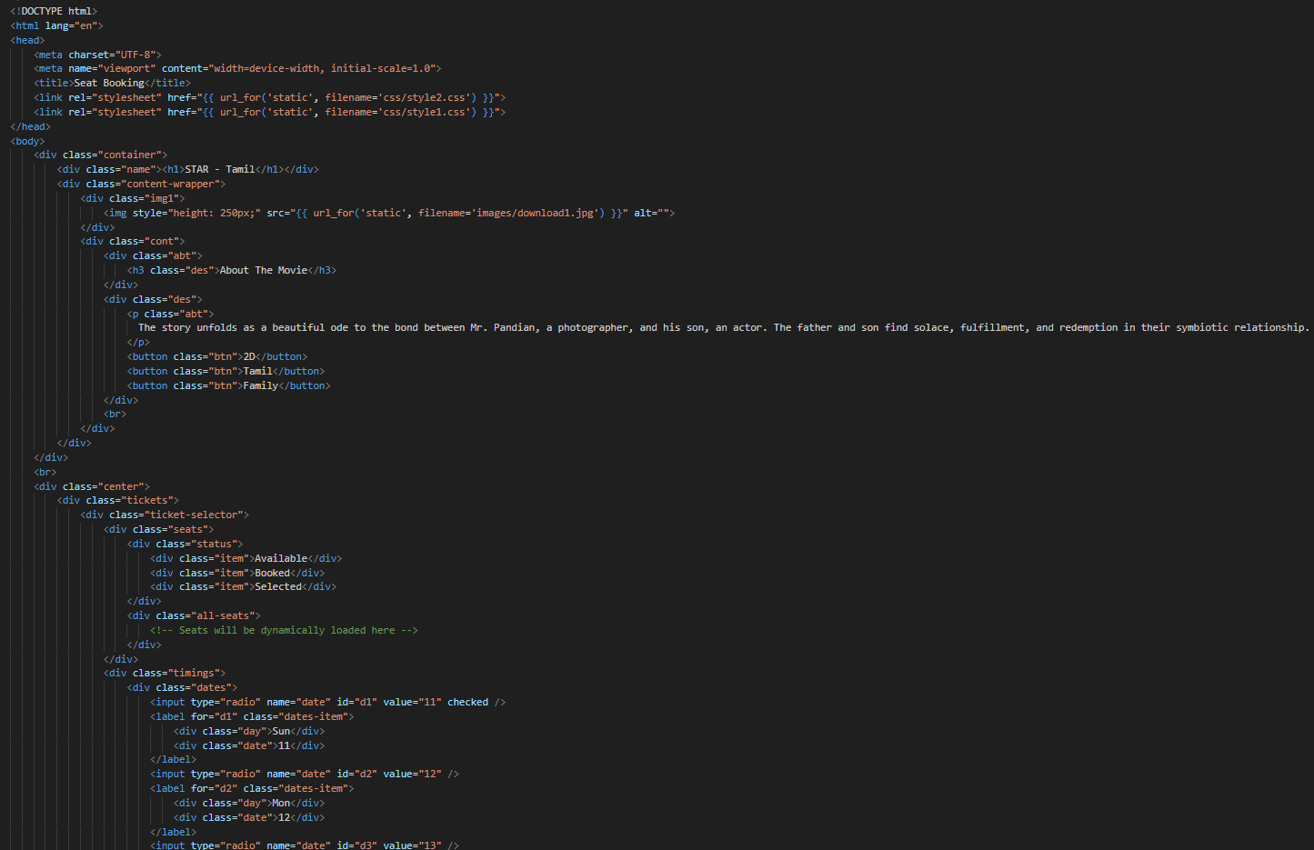





5.5 book3.html

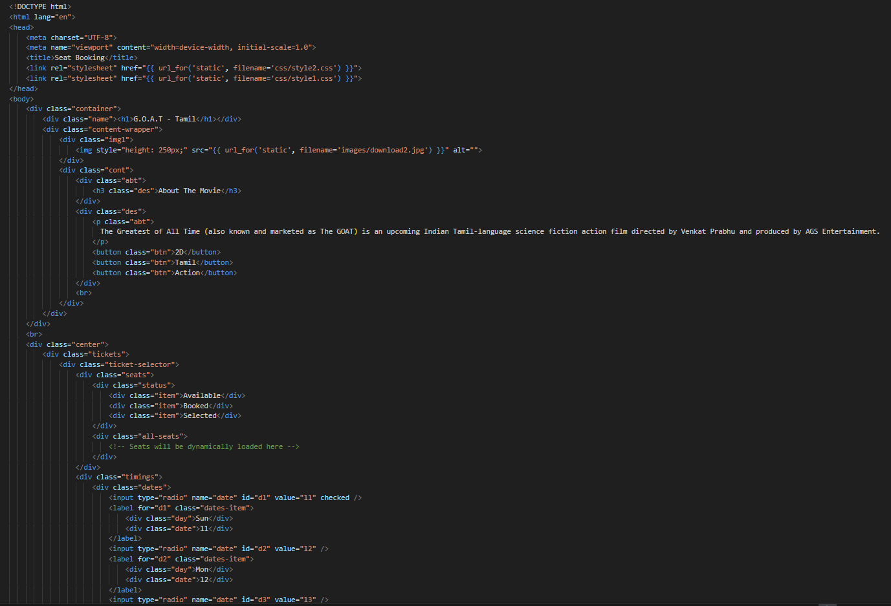





5.6 book4.html

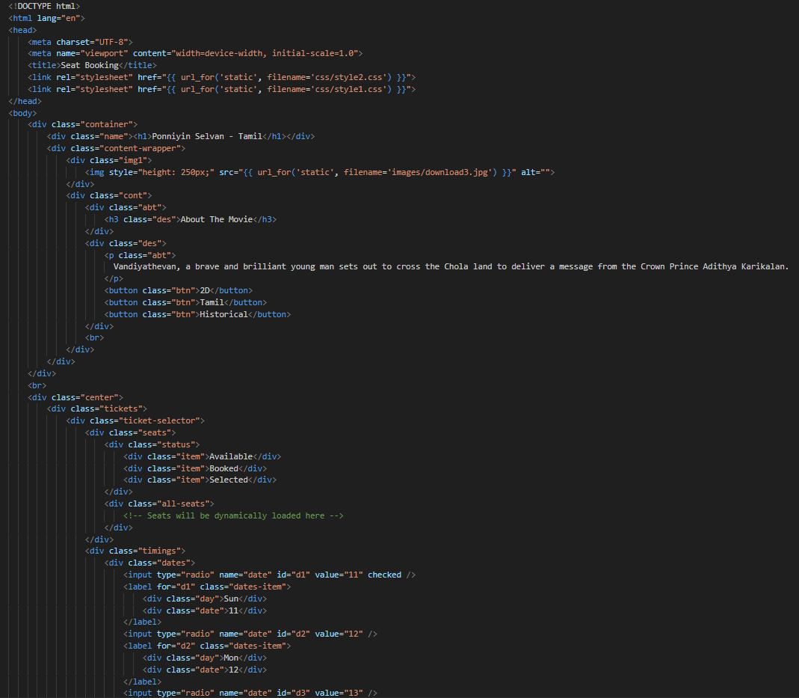





5.7 transaction.html

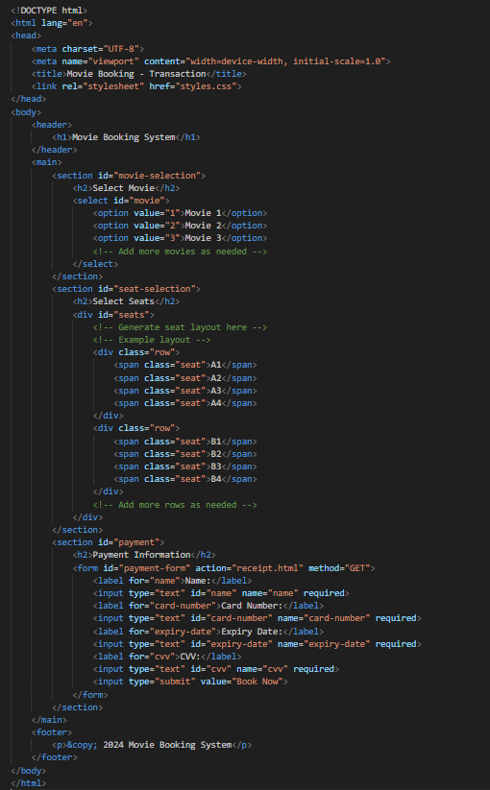

5.8 receipt.html

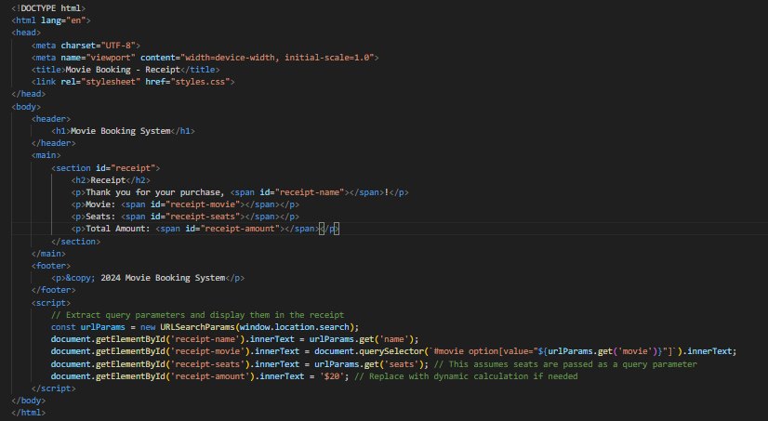

5.9 main.py

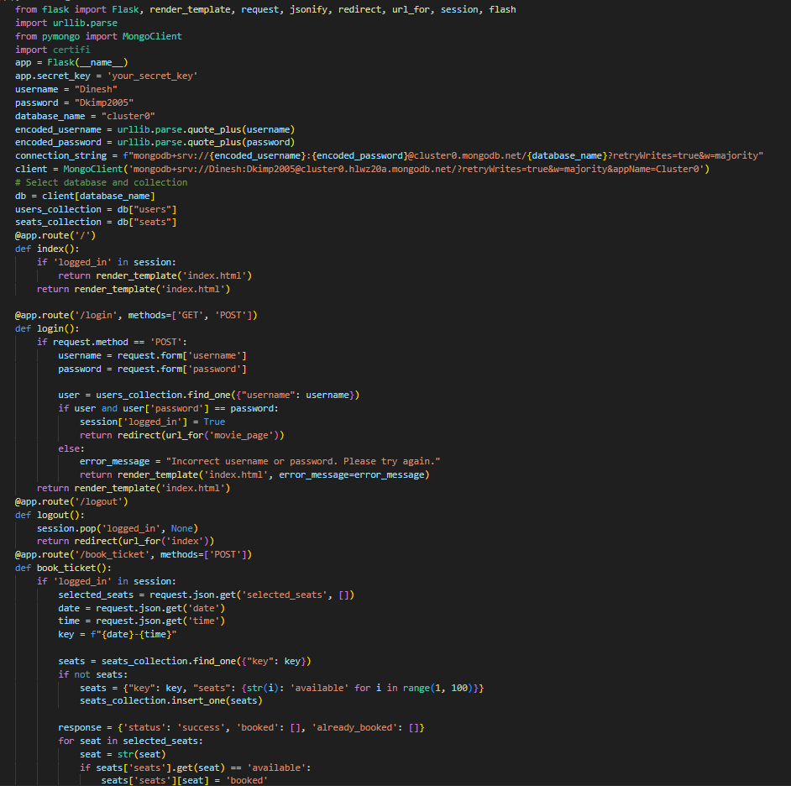

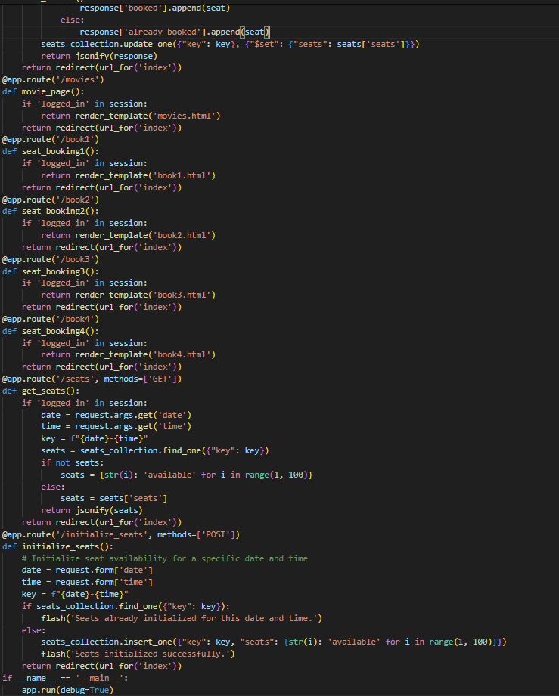

1. **Result - Snap Shots**
2. User login module

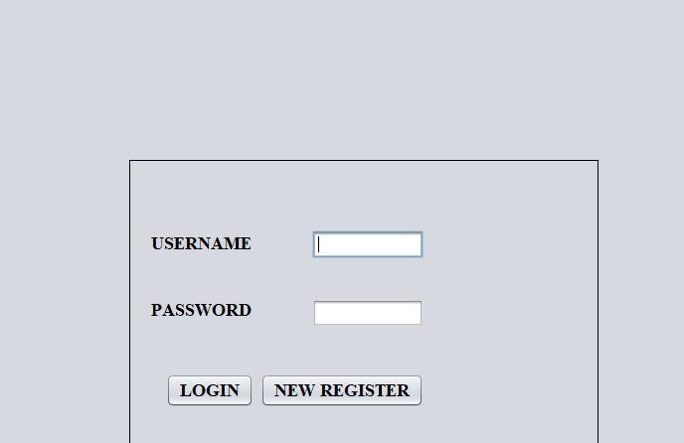

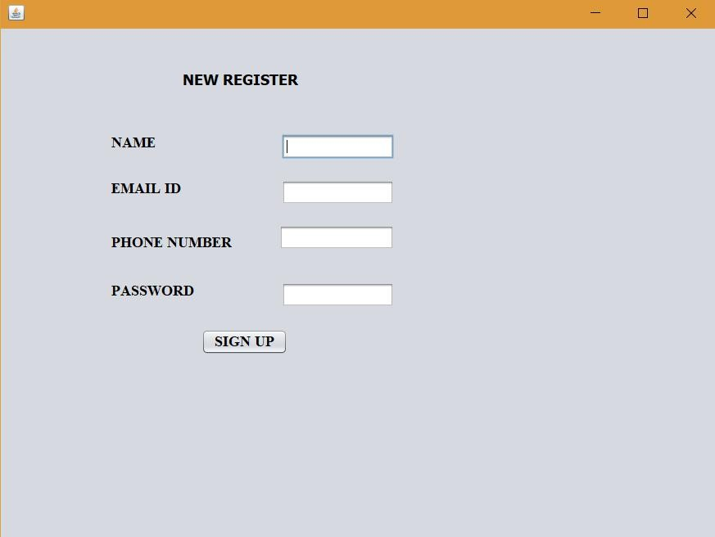2. New registration module:

* 1. Selection of Movie time, date, theater and ticket details:

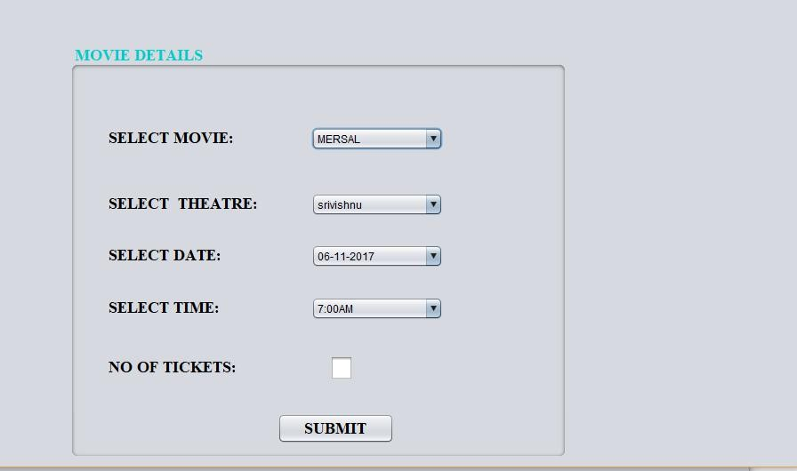

* 1. 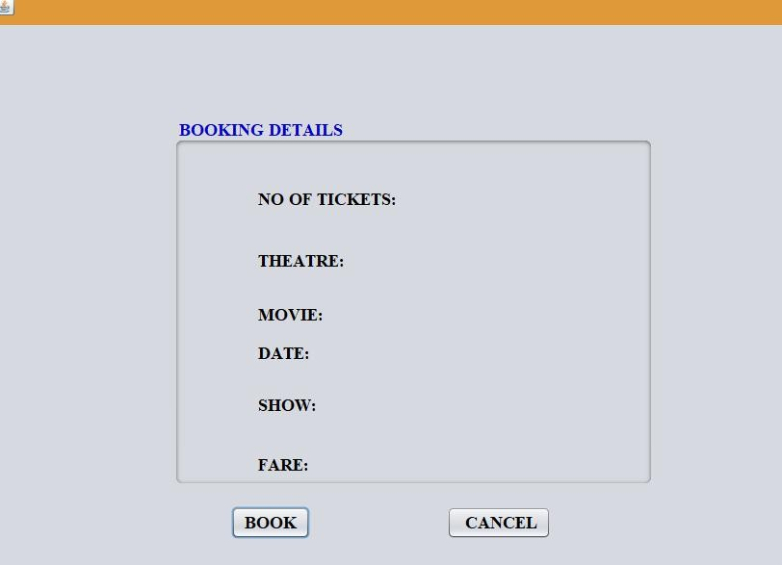Book ticket:
  2. Cancel ticket:

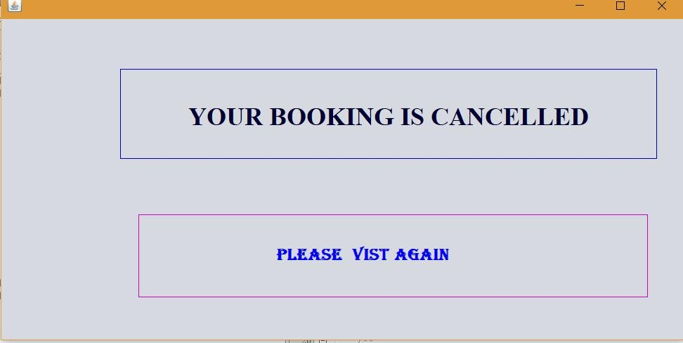

* 1. 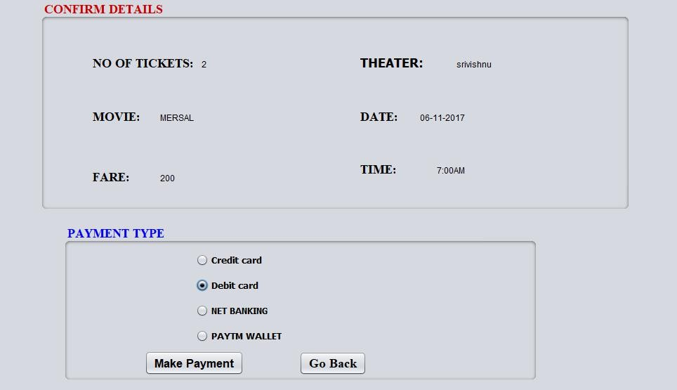Card selection:
  2. Card details:

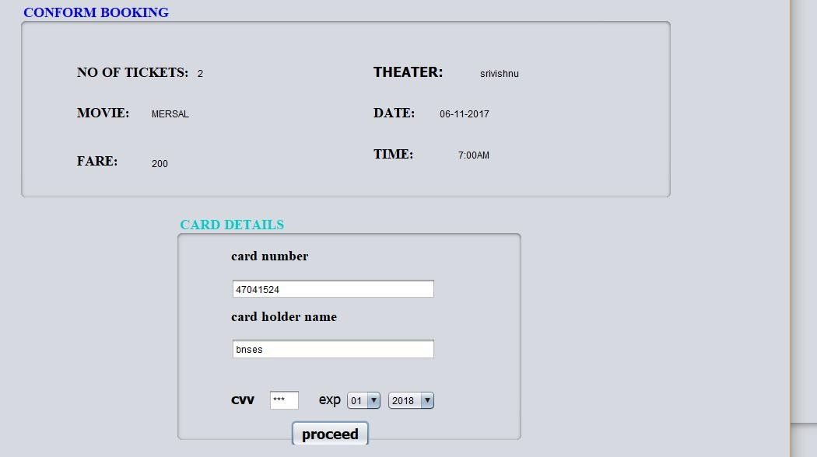

* 1. 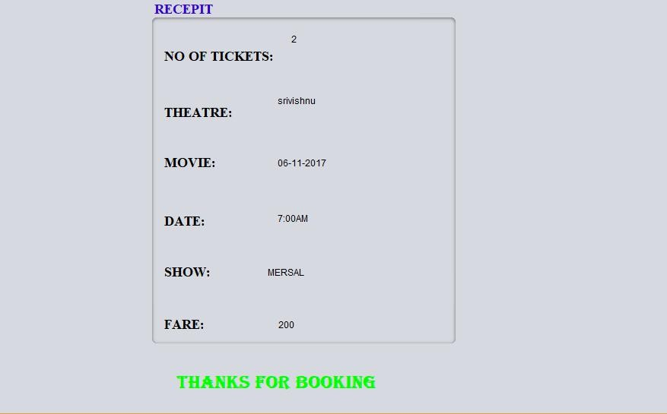Generating Tickets :

# 7. Result and discussion:

So, First we login to the system with username and password that we already data has been fed into the database. Then it takes into another page where we select movie and then after we selecting movie another page comes then we select show timings. After selecting show timings it takes into another page there we select number of tickets we want. After selecting number of tickets it takes into another page there we print ticket with cost.